# Using Machine Learning VM in Google Cloud Platform

Go to AI Platform -> Notebooks

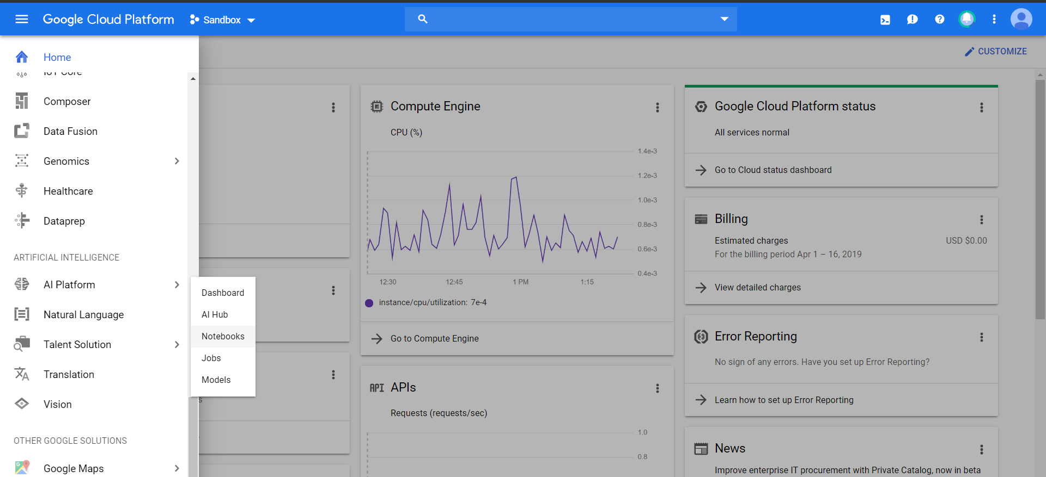

Select with GPU for speedy processing:

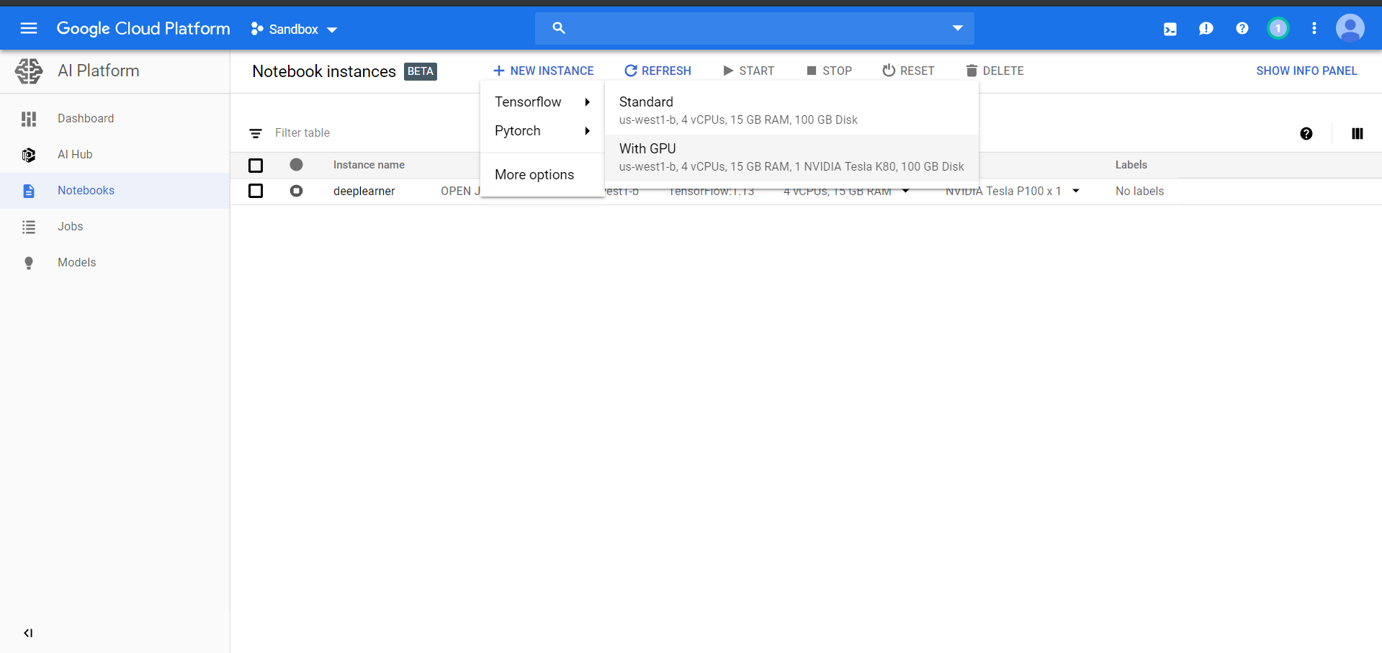

The cost is given for a month but the will be charged for per hour usage. 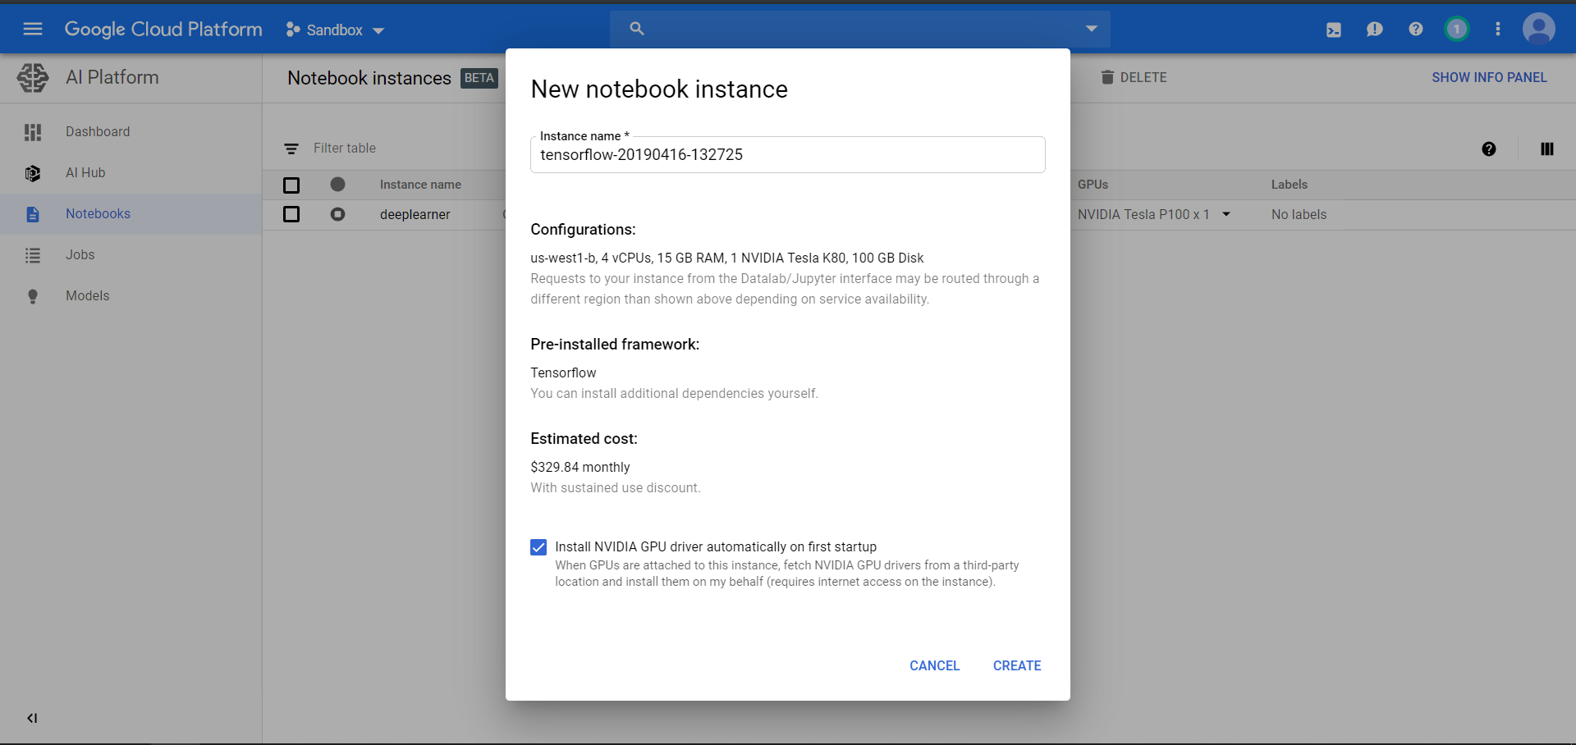

Once the machine is up click on Open JupyterLab

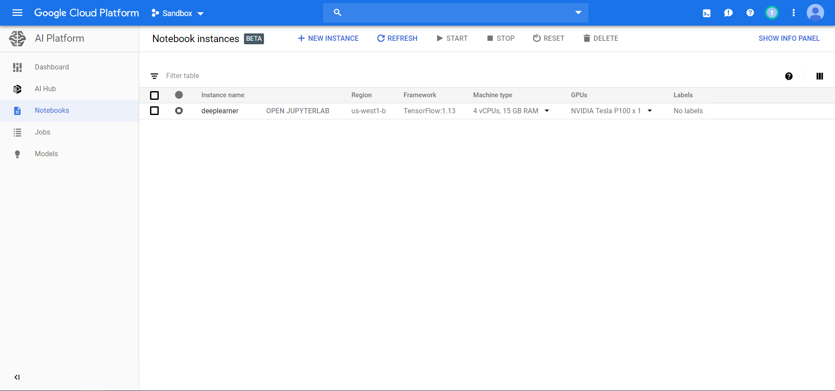

Jupyter Lab: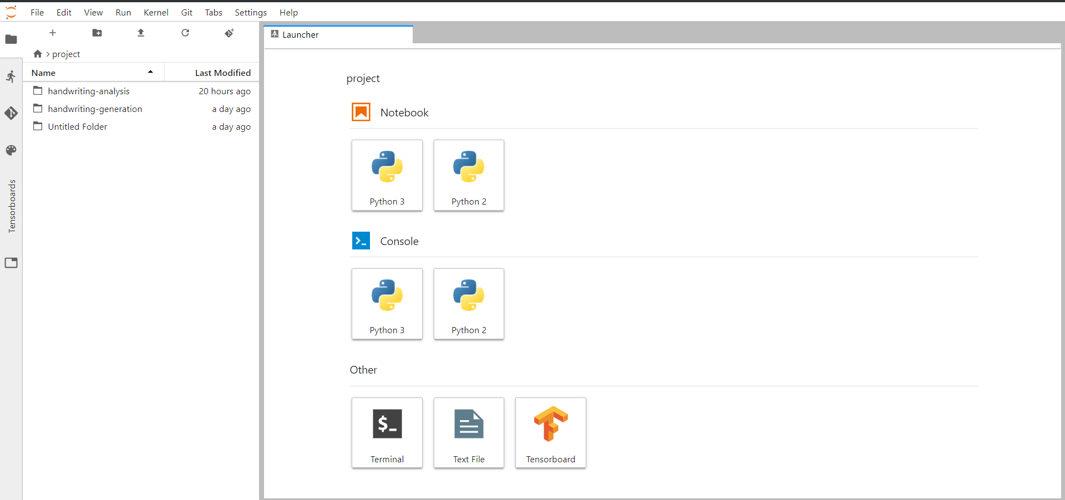

Drag drop files here to upload

This allows us to clone from git

This allows us to create a Python shell

This allows us to create a Jupyter notebook

For accessing VM with SSH:

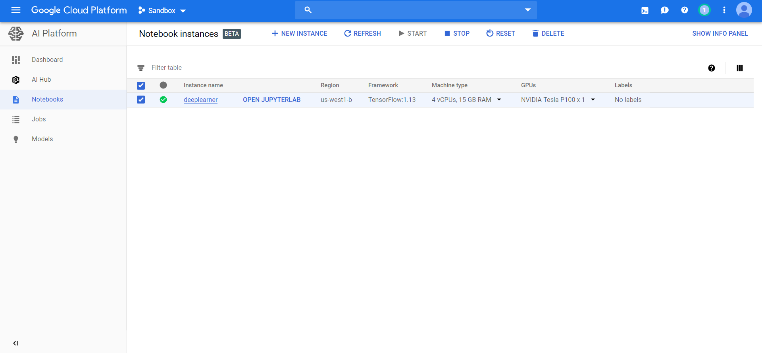

This will open the detail about the VM details

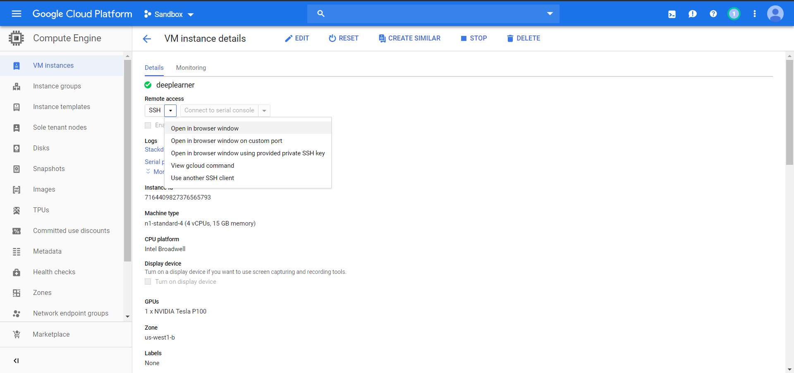

This open a SSH shell for the machine

To download and upload file follow the below link:

<https://cloud.google.com/compute/docs/instances/transfer-files>